**Osanai, Kaoru (小山内　薫　1881-1928)**

Christopher Gregory, University of California, Berkeley

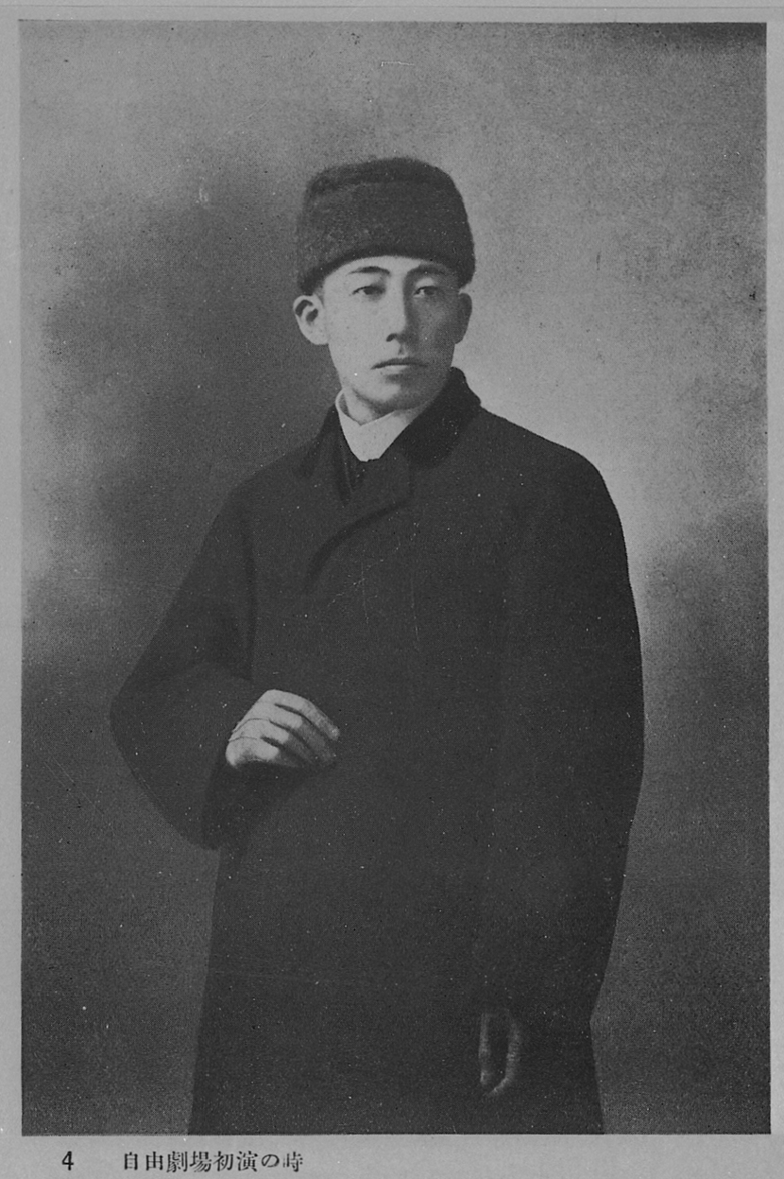

Portrait of Osanai Kaoru at the time of the Free Theater’s Inaugural Performance, 1909

url:

http://www.ndl.go.jp/portrait/datas/250\_1.html

This image is freely available online on the website for the National Diet Library of Japan. The National Diet Sources the image to *The Complete Works of Osanai Kaoru: Volume 1* ([小山内薫全集 第1巻](http://id.ndl.go.jp/bib/000000792562" \t "_blank)). The National Diet Library’s records for that book at the following URL:

https://ndlopac.ndl.go.jp/F/?func=find-c&amp=&amp=&amp=&amp=&amp=&amp=&ccl\_term=001%20%3D%20000000792562&adjacent=N&x=0&y=0&con\_lng=jpn&pds\_handle=&pds\_handle=

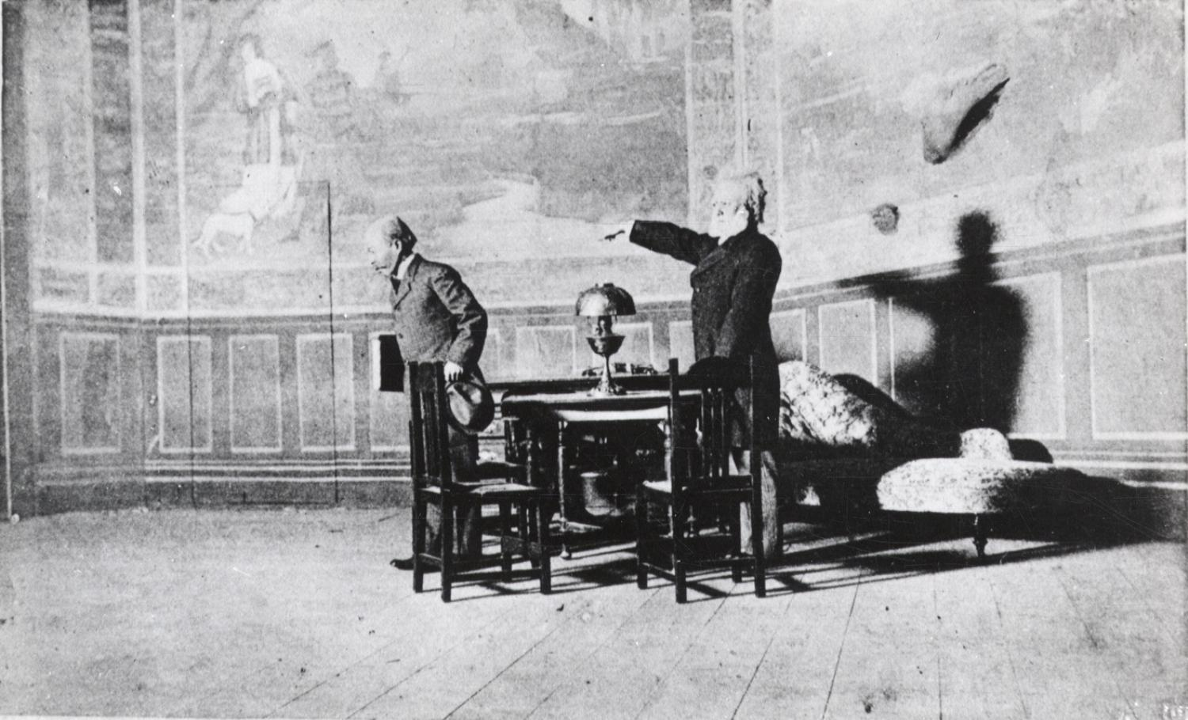

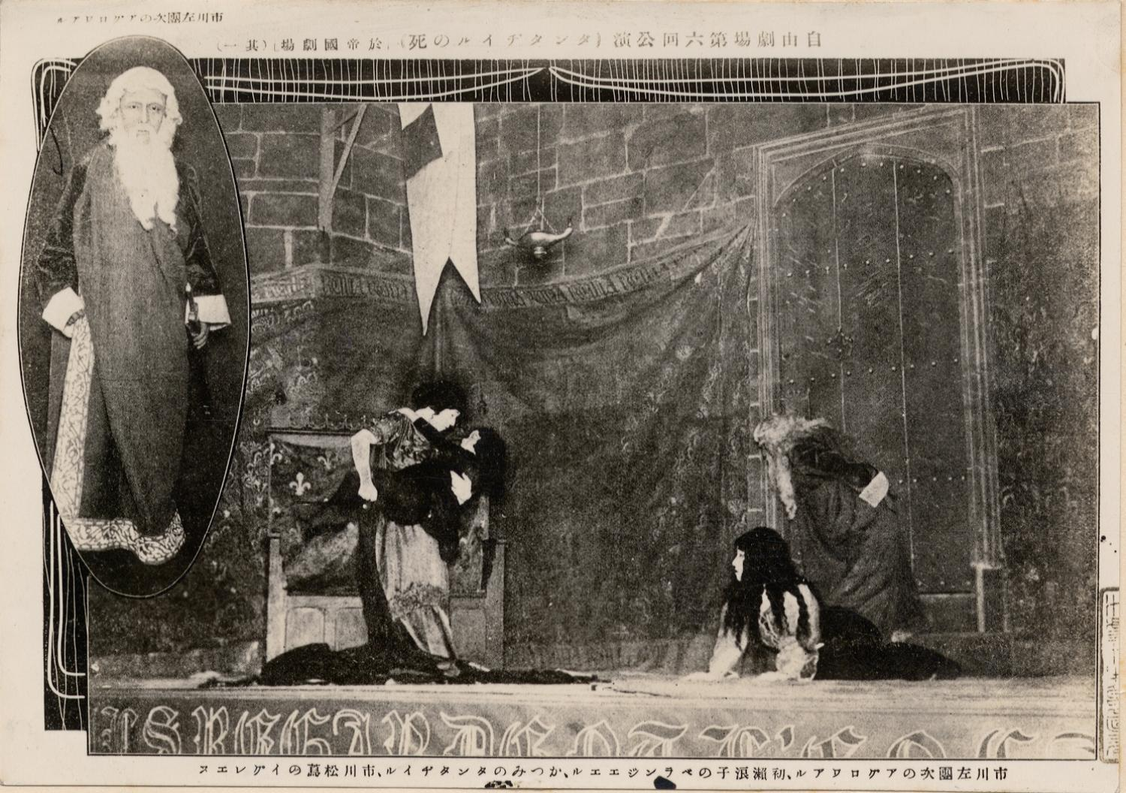

The Free Theatre’s Production of Henrik Ibsen’s *John Gabriel Borkman*, 1909

This photograph is available at the Waseda University Theater Museum Database for Theater Research. To access it, log in using “guest” for username and password the following URL:

http://www.enpaku.waseda.ac.jp/db/enpakuphoto/

Then, search for the following call number:

F54-00843

The Free Theatre’s Production of Maurice Maeterlinck’s *The Death of Tintagiles*, 1912

This photograph is available at the Waseda University Theater Museum Database for Theater Research. To access it, log in using “guest” for username and password the following URL:

http://www.enpaku.waseda.ac.jp/db/enpakuphoto/

Then, search for the following call number:

F54-06707

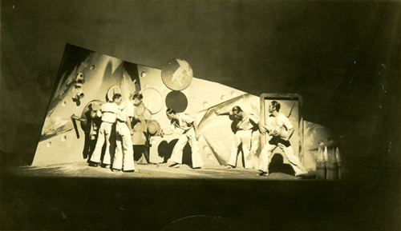

The Tsukiji Little Theatre’s Production of Reinhard Goering’s *A Navel Encounter*, 1924

The URL for this photograph is:

<http://www.tokyoartbeat.com/tablog/entries.ja/wp-content/uploads/2011/10/butai_1924.jpg>

However, I believe I will be able to get a better quality version of this picture (or additional alternate pictures) once the Waseda University Theater Museum reopens at the end of summer break in late August. Their public database only lists pictures through 1913, but it should be no problem to receive data for photographs of Osanai related performances from the 1910s and 20, because copyright has already expired. (Also, I’m currently a visiting researcher at Waseda University and regularly meet with the head curator and staff.)

Osanai Kaoru was a central figure in the development of both naturalist and modernist theatre in Japan, and he is best known for his work as a director, critic, translator, and playwright. In 1909, Osanai and kabuki actor Ichikawa Sadanji (1880-1940) founded the *jiyūgekijō* (自由劇場 Free Theatre), a theatre company devoted to introducing translated Western texts to Japan. For the Free Theatre’s inaugural performance in that same year, Osanai directed a Japanese language production of *John* *Gabriel Borkman* (1896) by Henrik Ibsen (1828-1906). This naturalistic production is frequently considered to be the first performance in the Japanese theatrical genre known as *shingeki* (新劇New Theatre). The Free Theatre continued to stage both Western plays in translation and also some new plays by Japanese playwrights until it dissolved due to financial difficulties in 1919. In 1924, Osanai joined with former pupil Hijikata Yoshi (1898-1959) to build the Tsukiji Little Theater and also to create a theater company of the same name. In addition to naturalist plays, the Tsukiji Little Theater staged German expressionist productions and, later, modernized kabuki classics with an emphasis on spectacle and mass appeal. Osanai also produced and starred in the silent film *Souls on the Road* (1921) and wrote Japan’s first radio play, ‘In the Mines’ (1925).

Osanai was a practical reformer and an intellectual leader during an era of rapid change in Japanese theater, and his conception of what New Theater should be shifted over time. He writings do not provide a systematic and consistent statement of what New Theatre should be. As such, defining what the New Theater was for Osanai is a subject of controversy, both during his lifetime and in the field of Japanese theater history.

One consistent feature of Osanai’s definition of New Theater was that it should be neither kabuki nor *shinpa* (新派). *Shinpa* a was melodramatic and often political genre of theater from the late nineteenth century that staged modern plays from Japan and adaptations of Western classics, but its language and performance conventions retained strong ties to traditional kabuki. However, even though Osanai defined New Theater in opposition to kabuki and *shinpa*, he continued to have a complicated relationship with both forms. Osanai was himself a former *shinpa* professional. In 1904, five years before founding the Free Theater, he took a job writing *shinpa* adaptations of Western dramatic texts at Ii Yōhō’s (1871-1932) Masagoza theater. Additionally, unlike his contemporary New Theater rival Tsubouchi Shōyō (1859-1953), who trained amateurs to act in a new naturalistic style, Osanai’s goal as stated in his ‘Plan for the Free Theater’ (1909) was to turn professional actors from kabuki and *shinpa* into amateurs for the New Theater’s naturalistic productions.

At the time Osanai founded the Free Theater, he conceived of New Theater as a theatrical genre that focused primarily on translating foreign language dramatic texts into Japanese and performing those dramatic texts in a style derived from Western theatrical naturalism. In this way, the New Theater of Osanai’s early Free Theater was largely an extension of the naturalist literary movement in Japan. However, after seeing productions directed by Konstantin Stanislavski (1863-1938) and Gordon Craig (1872-1966) during a trip to Russia and Europe in the years 1912 and 1913, Osanai began to instead advocate for theater as an independent art, separate from dramatic literature. In Osanai’s ‘A Message Regarding “The Free Theater”’ (1913), he suggested that his previous plays had been nothing more than introductions to literary texts, not theater as an art form in its own right. Osanai’s advocacy for New Theater to become an independent art form is in line with a global shift in the early twentieth-century modern theater away from the centrality of a dramatic text and toward a director’s unifying dramatic vision. This shift is also expressed in, for example, Gordon Craig’s ‘The Actor and the [Ü](http://www.oxfordreference.com/view/10.1093/acref/9780198601746.001.0001/acref-9780198601746-e-4017)ber-Marionette’ (1908), a text that helped shape Osanai’s conception of theater.

Although both Osanai and New Theater are often discussed as the movement that introduced naturalist and realist theater to Japan, Osanai’s Free Theater and the Tsukiji Little Theater also played a significant role in introducing non-realist and non-naturalist works. In his 1921-1922 “Little Theaters and Big Theaters,” Osanai made his anti-realist stance clear:

From the perspective of the global art movement, realism has already been excommunicated. It is in exile. In the worlds of painting, sculpture, literature, and theater, you certainly no longer see realism among the works of the highest quality. This is of course true for music and dance as well. In Japan, it appears that pitiful playwrights of the likes of Kikuchi Kan [1888-1948], who still think that dramatic texts must be realist, who still think that the theatre must be realist, continue to occupy a position of great stature. However, even before the Great War [World War I], a new wind had begun to stir. This wind risked its life to escape from horrific fires of war that we in Japan could not even begin to imagine. As soon as the war ended, this wind whipped its way through all of Europe. I believe that, in the near future, this whirlwind of the new art movement will certainly destroy Japanese realism (which is nothing but an aspect of bourgeois literature).

Even before this provocative statement, Osanai’s Free Theater staged symbolist dramas, such as a 1912 production of Maurice Maeterlinck’s (1862-1949) *The Death of Tintagiles* (1894), translated by Osanai himself. Later, the Tsukiji Little Theater’s inaugural performance in 1924 featured Reinhard Goering’s (1887-1936) expressionist work *Naval Encounter* (*Seeschlacht*, 1917), and Osanai wrote pieces like ‘Research into Expressionist Dramatic Texts’ in order to introduce German expressionist theatre to Japan.

In a 1927 lecture on ‘The Future of Japanese Theatre,’ Osanai expressed interest in drawing on not only Japan’s kabuki tradition but also theatre practices from Asian countries including China and India. This turn to Asia to inspire modern theatre was again in synch with global modernist trends in theatre, shared by contemporaries like Vsevolod Meyerhold (1874-1940). In 1928, Osanai pursued his boundary crossing fusion of modernist and classical theatre when he scripted a modernized adaptation of Chikamatsu Monzaemon’s (1653-1725) *The Battles of Coxinaga* (1715), which was performed at the Tsukiji Little Theatre just two months before his premature death.

**Major editions of collected works**

Osanai K. (1975). *Osanai Kaoru zenshū [The Complete Works of Osanai Kaoru]* (Vols. 1-8). Kyoto: Rinsen Shoten.

小山内薫. (1975). 小山内薫 全集 (第１巻〜第8巻). 京都: 臨川書店.

Sugai Y. (Ed. And Commentary). (1964-1968). *Osanai Kaoru engekiron zenshū [The Complete Theatre Theory of Osanai Kaoru]* (Vols. 1-5). Tokyo: Miraisha.

菅井幸雄. (編集・解説). (1964-1968). 小山内薫演劇論全集 (第１巻〜第５巻). 東京:未来社.

**Selected list of theatre theory and criticism**

“Plan for the Free Theatre” (自由劇場の計画, 1909)

“A Message Regarding ‘The Free Theatre’” (「自由劇場」の口上, 1913)

“Ibsen’s Grave,” (イプセンの墓, 1917)

“Little Theatres and Big Theatres,” (小劇場と大劇場, 1921-1922)

“Kaiser’s *From Morn to Midnight* (An Introduction to an Expressionist Play),” (カイザアの『朝から夜中まで』, 1922)

“The Tsukiji Little Theatre and Me” (築地小劇場と私, 1924)

“For What Purpose Does the Tsukiji Little Theatre Exist?” (築地小劇場は何の為に存在するか?, 1924. This piece is translated in Brian Powell’s ‘Japan’s First Modern Theatre,’ listed under “Further reading in English” below.)

“Research into Expressionist Dramatic Texts,” (表現主義戯曲の研究, 1925)

“The Future of National Theatre,” (国劇の将来, 1926)

“Theatre and Society,”(演劇と社会, 1926)

“The Future of Japanese Theatre,” (日本演劇の将来, 1927)

“Postscript Regarding the Adaptation of *The Battles of Coxinaga*,” (『国性爺合戦』改作追記, 1928)

**Selected list of other works**

*Ōkawabata*, (大川端, 1911, autobiographical novel)

*The First World*, (第一の世界, 1921, one-act play)

*The Husband*, (亭主, 1925, one-act play)

*The Trap Cellar*, (奈落, 1926, one-act play)

*The Battles of Coxinaga*,(国性爺合戦1928, modern adaptation of Chikamatsu Monzaemon classic)

**Further reading in English**

Morinaga, Maki I. (2005) ‘Osanai Kaoru’s Dilemma: “Amateurism by Professionals” in Modern Japanese Theatre’, *TDR: The Drama Review*, 49 (1): 119-133.

Ottaviani, G. (1994) ‘“Difference” and “Reflexivity”: Osanai Kaoru and the *Shingeki* Movement’, *Asian Theatre Journal* 11 (2): 213-230.

Powell, B. (1975) ‘Japan’s First Modern Theater: The Tsukiji Shōgekijō and Its Company, 1924-26.’ *Monumenta Nipponica* 30 (1): 69-85.

Powell, B. (2002). *Japan’s Modern Theatre: A Century of Change and Continuity*, London: Japan Library.

**Further reading in Japanese**

In addition to the works listed below, the commentaries by Sugai Yukio in *The Complete Theatre Theory of Osanai Kaoru*, listed above, are particularly important to scholarship on Osanai.

Mizushina H. (1954) *Osanai Kaoru to tsukiji shōgekijō [Osanai Kaoru and the Tsukiji Little Theatre]*, Tokyo: Machida Shoten.

水品春樹. (1954) *小山内薫と築地小劇場*, 東京: 町田書店.

Soda H. (1999) *Osanai Kaoru to nijūseiki engeki [Osanai Kaoru and Twentieth Century Theatre]*, Tokyo: Bensei Shuppan.

曽田秀彦. (1999) *小山内薫と二十世紀演劇*, 東京: 勉誠出版.

Ōzasa Y. (1985) *Nihon gendai engekishi: meiji・taishō hen [The History of Contemporary Japanese Theater: The Meiji and Taishō Eras]*, Tokyo: Hakusuisha.

大笹吉雄. (1985) *日本現代演劇史. 明治・大正篇*, 東京:白水社.

Ōzasa Y. (1986) *Nihon gendai engekishi: taishō・shōwa shoki hen [The History of Contemporary Japanese Theater: The Meiji and Early Showa Eras]*, Tokyo: Hakusuisha.

大笹吉雄. (1986) *日本現代演劇史. 大正・昭和初期篇*, 東京:白水社.